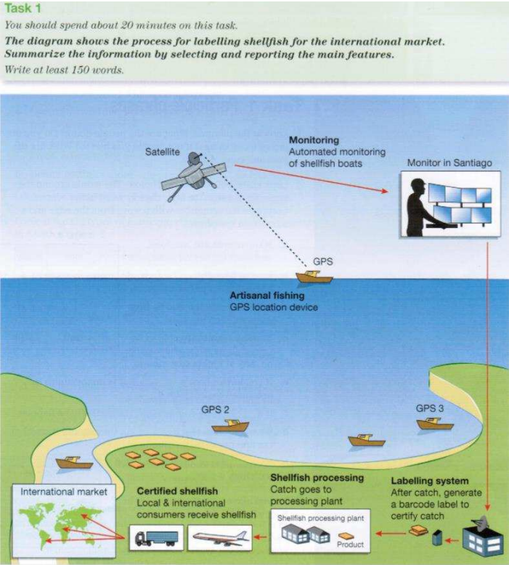

**Task1**

The picture below shows a complete process of labelling shellfish, and the products will be sold all around the world, in this essay I ‘m going to depict the main features of the process.

As you can see in the diagram, there are many ships equipped with GPS far away from the shore looking for shellfish. These boats are located by Satellite which will help the engineers working in Santiago monitor the movement of these boats. When the boats return with shellfish, the Labelling system is about to generate a barcode label to certify every catch. After the process of Labelling system, the catch will go to processing plant. In the plant the shellfish will be produced to many kinds of products. Finally, the products are sold to native and international market by trunks or planes. The consumers all around the world will receive shellfish.

Above all, it’s a brief summary of the modern shellfish processing.

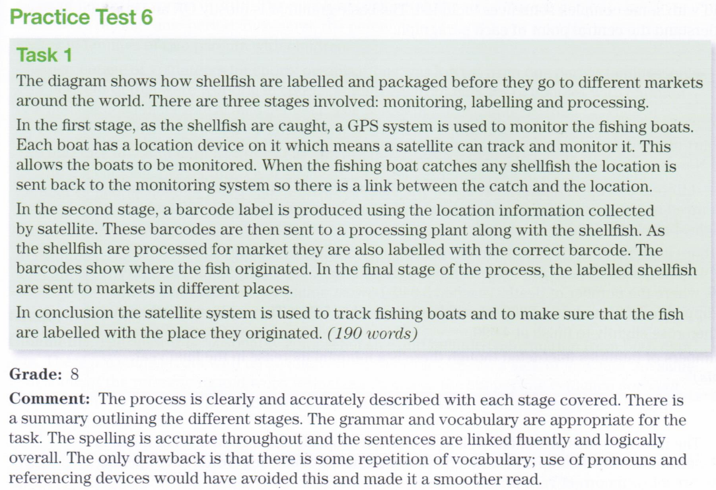

Cui

This flow chart illustrates **several stages** involved in the process of labelling shellfish for the global market.

Overall, the raw material, shellfish, pass through six stages before being a certified shellfish, from the initial stage of catch to the eventual qualified product which can be exported to other countries.

At the first stage of a certified shellfish, the raw material, shellfish ~~which is~~ living under the sea are caught by several boats which are automatically monitored and also located by satellite. Subsequently, a barcode label is produced to make the caught shellfish a qualified product.Next, shellfish~~es~~ are transported to the processing plant in which the original shellfishes get packaged .

Stage four involves how the products are transported to the customers. There are mainly two kinds of ways: land and air transportation. Finally, those certified shellfishes are transported to their final destination, global markets including continents like Eurasia，Africa and south America.

7分

GUO

The picture illustrates that the process in which labelled shellfish is supplied for the global market.

It is clear that there are six steps in this process. The process begins with collecting information from GPS and ends of the market.

At first, satellite will locate various artisanal boats through GPS and collect the information which is form automated monitoring of shellfish boats sent to monitor center in Santiago. And then，staffs will pass the information to a labelling system ~~which~~ near land. In the next stage, after system catching the information. we can see that labelling system will transform information to a barcode. By doing this, it can ~~be~~ certify this catch activity.

In the last several steps, such as fifth stage, labels will be carried on the shellfish processing plant. In this process, labelling shellfishes almost be completed. Labelled productions are transformed to local &international consumers by vehicles and airplanes. Finally, consumers will dispatch productions to international market.

6-6.5分

WYM

This diagram shows the continuous process of modern labelling shellfish.

Overall, it consists of four main stages: monitored fishing, catch labelling, product processing, and worldwide shipping.

The first step is the running of automated monitoring system, which is located in Santiago and some monitors will focus on the screens. The system monitors all the artisanal fishing boats with GPS locating devices whether they are fishing or not. After the boats catch shellfish, monitors send a signal to the labelling system. Then, the labelling system collects the information and generates a barcode label to certify each of the catches.

The third step is that the shellfish processing factory with processing plant received the harvested shellfish, and process the raw catch to standard products. Finally, the international express will transport the certified shellfish products to the local market in every county and deliver the fresh products to every customer by airplane and trunks.

6.5-7

W

The diagram illustrates the procedure of certified shellfish production for the markets around the world.

Overall, shellfish pass through four stages before being labelled as ready for global market consumption.

In the first stage of labelling shellfish, artisanal fishing boats with GPS location devices are controlled by the monitor in Santiago. These boats can be automated monitoring through a satellite. Once shellfish have been caught, boats take the catch and come back to shoreside. Regarding the second stage, people in Santiago sent a signal to labelling system to generate a barcode label to certify the catch. Subsequently, the catch with the certified label goes to the processing plant together. Then, shellfish are produced into the final products. The last stage is that certified shellfish will be delivered to the local and international markets.

6分

KV

The graphic provides the information about how to label and certify shellfish for the global

market.

The first step is monitoring the fishing activities. If fishermen want their shellfish being certified, a

GPS location device shall be installed on their fishing boats. Through this device, the information

of the fishing boats can be automatically transferred to the monitor center on shore ~~where is~~ in

Santiago via the satellites on space. Therefore, the fishing activities, such as the location of the

boats and their operation time are monitoring in real time by the personal at the center.

After being caught, shellfish will be sent to the fish port where the local office is set up that can receive

information from the monitoring center in Santiago. If the catching process is fulfilled the

requirements according to the confirmation from the center, a barcode will be generated and

labelled to certify the whole shellfish.

Then the labelled shellfish goes to the processing plant for further treatment like frozen and

packing. Finally, these certified shellfish will be distributed to local and international consumers

through road transportation or airplane shipment from the process plant.

6.5-7分

PT.

This graph describes how the shellfish are labeled and distributed to markets all over the world with help of information technology.

Overall, all fish ships are monitored by satellites, as soon as they get their catch the information will be delivered to the Labelling system, where the barcodes are generated for certifying. Then the catch with a barcode will go to processing plant, and be distributed to local and international market by trucks or planes.

Firstly, information technology monitors the whole process of fishing and certifies the catch. There is a GPS location device on every **artisanal fishing boat** which makes it trackable by the satellite automatically. The date of location will transfer to a center in Santiago, monitored by humans and relayed to Labelling system.

After receiving the catch, the Labelling system generates a barcode for each batch. Then the certified catch is sent to processing plant, where the catch is processed into products and distributed to local and international markets.

6.5左右

**Task 2**



Many people in developed countries suffered a poor health situation with poor nutrition and obesity. Some people who thought it has a strong relationship about the fast food and the authority argue that a high tax on fast food may change the situation. I don’t agree with that.

Some believe health problems like poor nutrition and overweight in many western countries are due to the popularity of fast food and a tax can resolve the issue. I generally/absolutely disagree with such point of view. And this essay will discuss my reasons not to support such tax.

Firstly, the relationship among the fast food and poor nutrition and obesity is not identified. **When** they both eat healthy foods, some people with special genes are more easily to become fatter than others. Secondly jobs are also associated with health situation. Those people **who** have to spend their time on a seat whole day, like trunk driver, don’t have enough time to do exercise faced a risk of obesity.  **Even though** there are a proportion of people in poor nutrition was directly caused by the fast food, the problem will not be set down by this way.

Tax is always not a useful way to solve problems. It was just a method used by the authority to enlarge their power，control the society, and gain profits by it. Imposed tax on fast food would increase people’s living cost who really like eating fried chips and other fast food. And this may lead to a decline in the production of fast-food restaurant. The people who work for the restaurant may have a lower payment and even lost their job, that makes their situation worse, and finally, the unhealthy situation may cause the poor nutrition. +价格方面考虑

Above all, in my opinions, -> In conclusion,a tax on fast food would not reduce the problem. The efficient solutions were improving people’s income and with their situations getting better, they will have enough time to do some exercise or outdoor activities. Lastly, it’s important to wake people’s awareness of health.

6分左右

K

Nowadays, more and more people is concerned about the problem of lack of nutrition and

obesity emerging in developed countries. Some people suggest that tax on fast food could **improve the current situation**. Generally, I don’t agree with that suggestion. The details will be discussed in the paragraphs below.

**Firstly, imposing a tax specially on fast food for solve the problem is not justified**. As we know, fast food restaurants or producers can do business only when they fulfill some

regulations and should be taxed for normal business according to the laws.

Furthermore, poor nutrition is more likely caused by low income or poor financial condition in

many families. And obesity may not only because can be the result of various factors such as people’s over-intake of fast food, lack of excise or over consuming sugar which could be a primary reason according to statistic data provided by key/major organizations. So a tax on fast food is unjustified，even under the name of doing good. 句子写长了，需要回顾语法。

**Secondly, a tax on fast food may impact may people who work in this segment because** many people rely on the fast-food industry as not only big company or fast-food franchises but also small business entities are involving in producing fast food. To illustrate, if tax is imposed, thousands of people will be affected. Due to the tax increase, the cost may increase accordingly. As a result, many small businesses in fast food supply chain could be forced to close down and employees may lose their jobs. Therefore, a special tax on fast food may worsen the situation instead of improving it.

To conclude, a tailored tax on fast food is not fair for the industry and its employees as it may

lead to a worse scenario

6.5左右.

Some people believe that bad nutrition condition and overweight is triggered by **the prevalence of fast food** which should be heavily taxed to **alleviate the problem**. I partly agree with this assertion; while it may be effective to some extent, the essential solution of this problem is to change people’s living and dietary style.

On the one hand, to tax heavily on fast food or junk food companies could help to **curb the expansion** of fast food industry because(2) which would eventually **be conducive to** reduce people’s intake of fat and carbohydrate and would not suffer from poor nutrition and obesity1. With the prevailing of advertisement and stores of junk food, people cannot resist the temptation of hamburgers, chips or cokes句子中加上For example. **As a result,** more and more people choose to eat fast food which is convenient and delicious instead of eating healthy or time-consuming home-cooked food. Taxing more on fast food could increase the cost of the companies and stop them from paying a lot of money for advertisement and building new stores2. Without those temptation, people would choose other kind of dietary style which is healthier for their body.

On the other hand, it is also very important for people to keep a healthy living style and dietary style, so they can get away from bad nutrition condition and overweight. Nowadays, most people are living **a sedentary life style**, which means that they spend more time playing video games and binge watching videos or TV series than doing exercise. Because of the lack of exercise -> As a result, people are gaining weight. To make matters worse, due to **the high pace of work** and life, people prefer to order takeaway food which is high in oil and salt and is detrimental to their health. Only by exercising more and keeping eat healthy food, can we tackle the root of the problem related to bad health condition.

Statement+ explanation( 以前觉得不用说都懂的东西，也要进行解释，例如，鼓励人们运动因为运动可以提高心肺功能和消耗卡路里。）

In conclusion, taxing more on fast food industry is helpful to reduce the problem of overweight or malnutrition to some extent. But the most effective way should be forming a healthy living style.\

6.5-7分

从句不够的同学，可以参考大作文要用5个

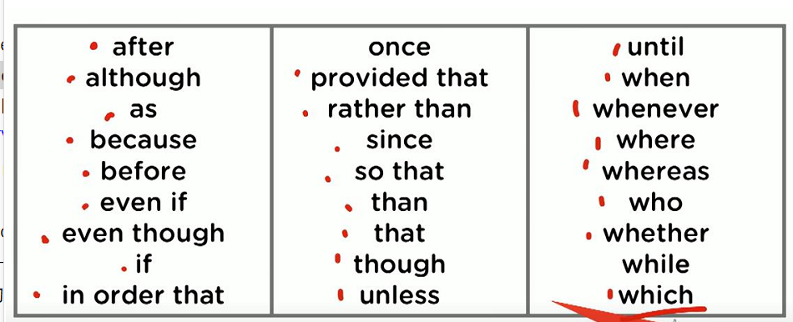



It is true that an increasing number of people are concerned about+ 问题 a healthy diet. Both lack of nutrition and being overweight become important issues today. Some people think that imposing taxes on junk food industries might decline -》 resolve the problems. In my point of view, I disagree completely. this essay will give some reasons.

Firstly, the obvious reason is that taxing fast food would lead to people paying more money for it. Although fast food might be bad for health, it still brings a convenient style of life for people. **For instance**, many people work in a long-distance -》distant place from home. They could not have enough time to go back home for cooking. At the same time, break time is limited. So fast food is a good way to fill their stomach. Moreover, it is common that people ~~to~~ work hard because of good salary. Food is a basic consumption in life. Increasing tax on fast food would cause more spending. **So** I think it might give high pressure on people.

The second reason is that a tax on fast food would reduce the total income of the local government. Because fast food is not a high-profit industry. **For example**, in our city, street food is a special scenery. This kind of fast food mainly relies on labor. **If** given more financial pressure, it is certain they would close business. +需要“废话”来论证**As a result**, the government would lose a part of its income.

In conclusion, taxes on fast food not only lead to a higher expense for people but also reduce the total income of the government. Although people should not ignore healthy diets and obesity, I think a tax on food is not the best way to solve the problems.

6分

PT

Many people are suffering from overweight and a lack of nutrition，which is a heated issue for many advanced regions. Some argue that governments should tax the companies that provide unhealthy food to improve this situation. I do not agree with this appointment, because fast food is not the only matter and tax is not the silver bullet for this.

**First and foremost, increasing tax on fast do not always change the pattern of people’s activities.** As we know, most of these people are poor and are used to eating food full of heat but lack nutrition, which is hard to change. Therefore, the companies can easily relay the growing cost to consumers. Consequently, people’s situation will get worse with the added tax. The unspected influence attributed to the same policies has been seen in many areas. Take, for example, the house price controlling policy in China: to avoid the increase of house prices, the government raised the tax of deals and interest of loan, but that did not works. 不要用举例结尾 ，需要+ as a result.... / + so 呼应你的观点

Instead of adding tax, governments should do more things to help people to change their diet habits. There are several ways to achieve the goal.-> other more effective measures include government subsidy and limit on fast food promotion. For instance, governments can allowance the healthy food by distributing food coupons. People can only use these coupons to buy food like whole wheat, eggs, vegetables, etc, but not the junky food. Another measure is to reduce the influence of fast food. Junky food has become a popularity nowadays with the overwhelming advertises in all kinds of media. Governments need to restrict these kinds of propaganda, and make more advertises for the healthy diet. By doing this, it will be easier for people to turn into a healthier diet. 不要用举例来举具体措施

To conclude, rather than increasing taxes on fast food with a bad influence, leading people to improve their diet habits is a more efficient measure.

6分

WYM

Some people believe this idea that fast food makes people more obesity and poorer health, and introduce a tax on fast food can benefit people. But I don't agree with it and believe this idea would exacerbate unhealthy problems.

The first reason is that there are lots of supervisors on fast food industry and fast food's nutrition are more balance and health already. Some people become obesity and poor nutrition because that they drink or eat more that they need, But it's not the problem of fast food. If the fast food get more expensive, those people can refer to some other kinds of food, such as sugar milk and donuts. So a better solution is to lead a restricted diet habit among obesity people and introduce a balanced diet to unhealthy people.

Besides, taxing on fast food would reduce all people's welfare, because fast food makes our life simple and happy. For examples, white-collar workers have not enough time to cook for themselves, and fast food gives them more time to rest. Poor people can also get enough nutrition from fast food at a reasonable price, but when the tax law comes out, the fast food will be more expensive and people have to chose another cheep food, which is a new reason for someone to tax. Therefore, the purpose of taxing on fast food maybe good, but the results will be a big trouble for the whole society.

For the reasons above, taxing on fast doesn't help to increase people's health and would create a new burden. 6-6.5分

XC



It is clear that lack of nutrition and obesity is becoming a serious issue in many developed countries. Some people argue that government should tax the fast food companies to solve this problem. In my view, I'm afraid I have to disagree with that opinion.

**Firstly, a tax on fast food only makes people who eat takeaway dishes turn to other unhealthy alternatives. 缺乏解释** Obviously, fast food costs less than healthy eating. For instance, fast food contains more sugar and trans fats than organic food, but eating food with more protein and healthy fat means people have to spend more money on that. Besides, people who have to go to the job or attend school do not have plenty of time to prepare healthy food. Instead, they are more likely to eat hamburgers or sandwiches, which are more convenient. 快餐加税会让人们寻找其他不健康的替代品,因为吃快餐的人部分是因为时间问题。

**文章的内部意思的推进很重要**

Secondly, People who choose fast food are usually with lower income. For example, A survey from a Chinese university showed that people with unhealthy eating habits are highly relevant to their poor salaries. For this reason, if the government tax on unhealthy food, it only makes poor families cost much more money on their foodstuff, which cannot eliminate malnutrition or obesity. Despite this, I believe that government can play an important role in this health issue. I think the government should provide more useful nutrition education, making the whole community aware of the importance of healthy eating.

举例和论点都需要是能够成立/理解的。

In conclusion, I argue that the tax on fast food cannot reduce health problems. Understanding the disadvantages of fast food may have more benefits for our community.

5.5-6

W

Because of the popularity of fast food in numerous rich countries, malnutrition and overweight become a problem to citizens. Some hold the opinion that government should tax fast food to decrease solve/resolve/alleviate the problem. This essay will discuss why I disagree with that in details.

我不赞成快餐加税

最明显的理由支持快餐是it provides the convenience and energy for people to live and work although fast food has high calories with less nutrition. Because many people have to work overtime or travel to remote places, fast food turns into their best choice. Sometimes, it is the only choice. **For instance,** a great number of truckers are traveling across the nation every day. Their job needs them to drive carefully and more importantly, they need to finish work in time. **Consequently,** they have to choose fast food restaurants or snacks. Government should not increase those people’s cost of living.

另外一个反对加税的理由是 fast foods are cheaper for poor people to purchase. Food expenditure is one essential part of household cost. Rich family are able to buy fresh foods and cook in home, but not poor family. They need less time and less cost to prepare a meal because they spend most time on work, or they do not have extra money to enjoy. It is clear that every country still has poor people that struggling for a basic living, such as America, France, China and so on. Cheap and convenient foods are their daily choice. Government should subsidize them instead of tax them.

In conclusion, fast food is a benefit to people who need to work hard, or who do not have a high income, despite its poor nutrition and obesity problems.加税不是让我们吃得更健康的办法，却会让人们经济负担更重因为选择它的人是由于工作时间要求和价格因素。

6分

